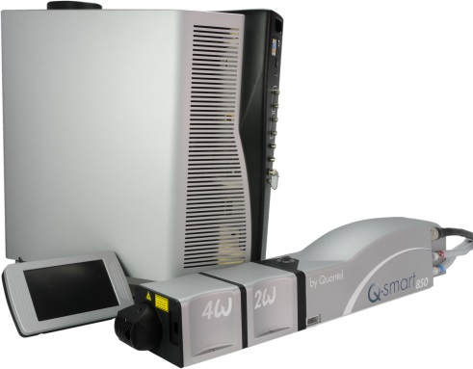**QSMART – DICHROICS AND OUTPUT BEAM DUMP REPLACEMENT PROCEDURE**

**Toolkit:**

Allen keys

**System**: QSMART

|  |  |  |  |
| --- | --- | --- | --- |
| **SM010362** | **Q-SMART 2ND HG DICHROICS ASSY** | | |
|  |  |  |  |
| **SM010364** | **Q-SMART 3RD HG DICHROICS ASSY** | | |
|  |  |  |  |
| **SM010366** | **Q-SMART 4TH HG DICHROICS ASSY** | | |
|  |  |  |  |
| **SM010368A** | **Q-SMART 5TH HG DICHROICS ASSY** | | |

|  |  |
| --- | --- |
| **SM010369** | **Q-SMART OUTPUT BEAM DUMP** |

**Purpose**: This document details how to change the dichroic and the output beam dump

|  |  |  |
| --- | --- | --- |
| Revision | date | modification |
| Initial issue | July 4, 2014 |  |
|  |  |  |
|  |  |  |
|  |  |  |

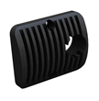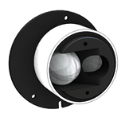

# Disassembly of the dichroic and the output beam dump

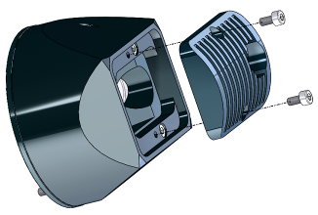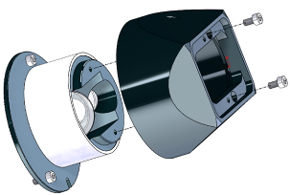

Unscrew and take the covers away.

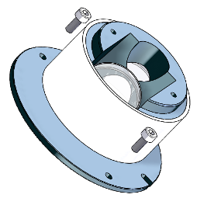 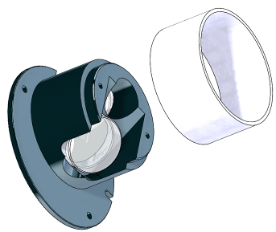

Unscrew and take the beam dump away.

# Implementation of the dichroic and the beam dump



Install the beam dump on the dichroic support

Fasten with 2 screw M3x8



Attach the cover with 2 screws CHC M3x6

Fasten the heatsink with 2 screws CHC M3x6 (check the direction)